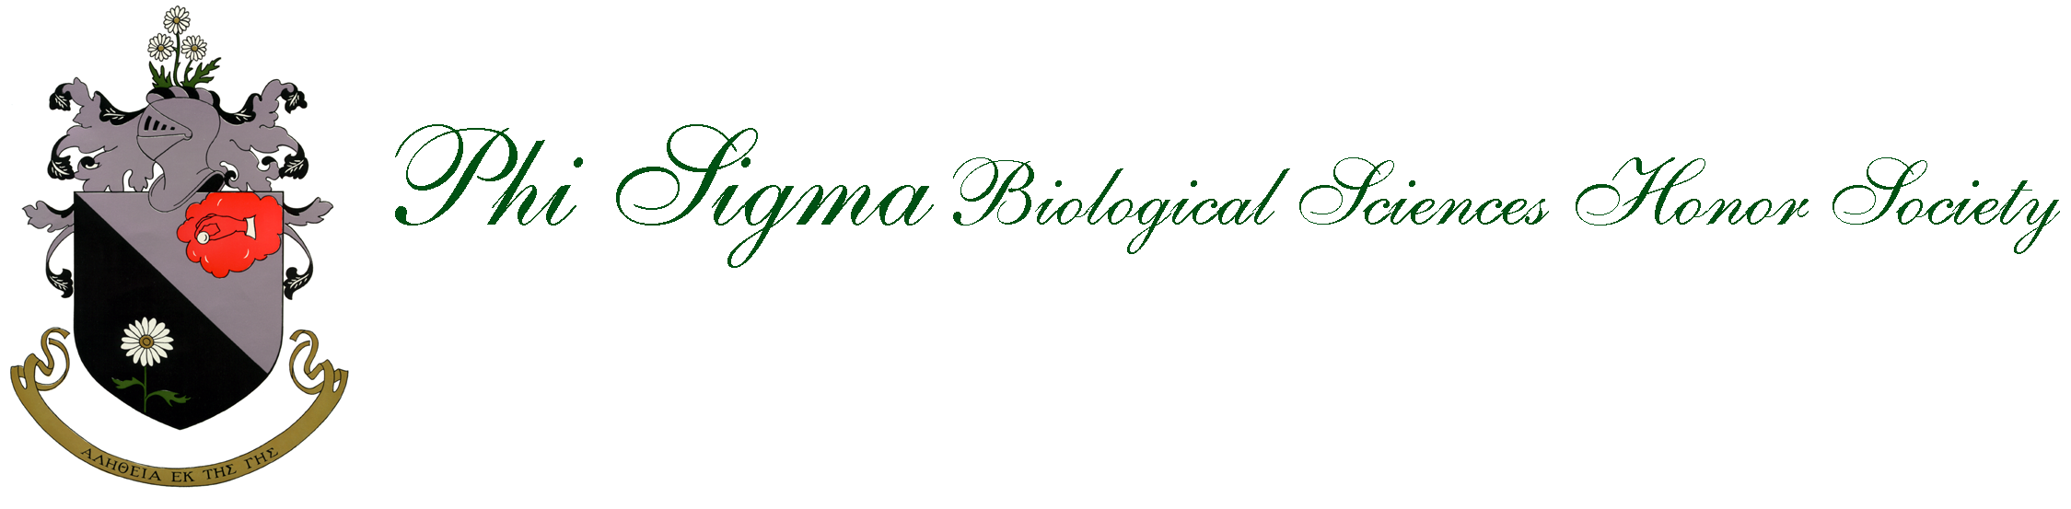
Devoted to the promotion of research and academic excellence in the biological sciences.
Member of the American Institute of Biological Sciences (AIBS) and Association of College Honor Societies (ACHS),
affiliate of the American Association for the Advancement of Science (AAAS)

